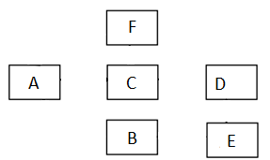

#include <iostream>

using namespace std;

class A {

public:

A() {

cout << "constructor A" << endl;

}

void f() {

cout << "A";

}

};

class B : public virtual A {

public:

B() {

cout << "constructor B" << endl;

}

void f() {

cout << "B";

}

};

class C : public virtual A {

public:

C() {

cout << "constructor C" << endl;

}

void f() {

cout << "C";

}

};

class E : public virtual C {

public:

E() {

cout << "constructor E" << endl;

}

void f() {

cout << "E";

}

};

class D : public virtual C, public virtual E {

public:

D() {

cout << "constructor D" << endl;

}

void f() {

cout << "D";

}

};

class F : public virtual A, public virtual C, public virtual D, public virtual E {

public:

F() {

cout << "constructor F" << endl;

}

void f() {

cout << "F";

}

};

int main() {

F object;

object.f();

return 0;

}